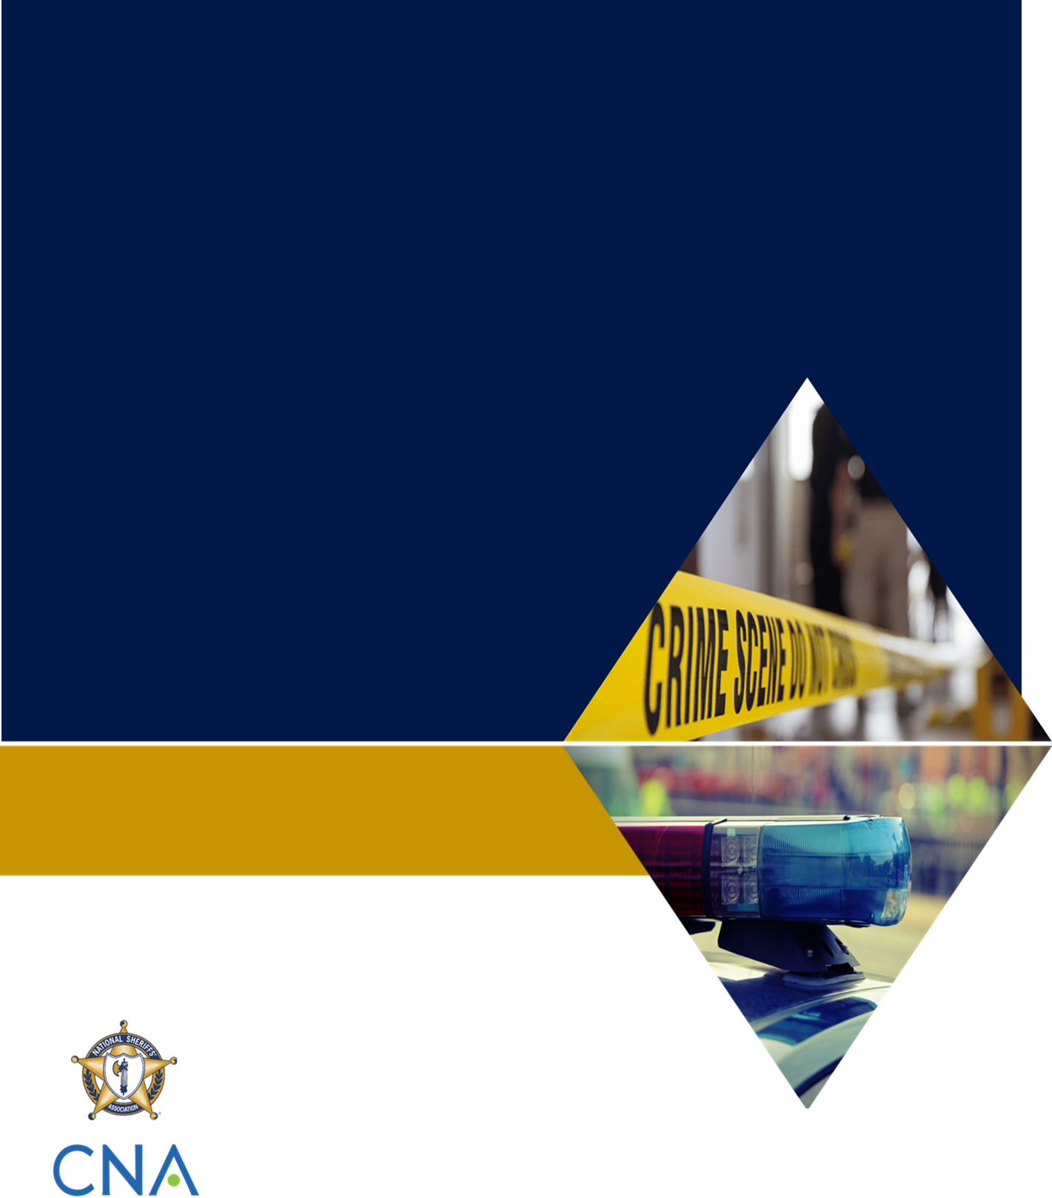
Table of Contents
[Insert Classification]
[Insert Name of Military Installation]
Active Shooter Response Tabletop Exercise
Summary Report

[Insert Date]
Insert your jurisdiction logo here
Table of Contents i
Handling Instructions iii
Introduction 1
Key Findings 2
Topic 1: Operational Background 2
Topic 2: Emergency Communications 2
Topic 3: Base Access and Incident/Unified Command 2
Topic 4: Tactical Operations 3
Topic 5: Public Information and Family Reunification 3
Improvement Plan 4
Appendix A: Exercise Participants A-1

Handling Instructions
- The title of this document is the [Insert Name of Military Installation] Active Shooter Response Tabletop Exercise: Summary Report.
- Information gathered in this document is designated as [insert classification and handling instructions].
- For more information about the tabletop exercise (TTX), please consult the following point(s) of contact:
Name
Position
Agency/Organization
Contact information

Introduction
Add an introductory paragraph providing the following information:
- When and where you held the exercise
- Who participated in the exercise
- Which topics you chose to cover
Our jurisdiction identified the following exercise objectives (if needed, modify the list below to match your chosen objectives):
- Provide a forum for agencies to communicate and collaborate on planning and response preparations for an active shooter incident on a military installation.
- Confirm the roles, responsibilities, lines of authority, and operations coordination of civilian law enforcement and military personnel during an active shooter incident on a military installation.
- Confirm proper channels for information sharing among civilian law enforcement and military personnel during an active shooter incident on a military installation.
- Confirm the process for coordinating public information, victim assistance, and family reunification following an active shooter incident on a military installation.
- Identify any gaps in planning, policy, or response coordination that would hinder response efforts.
The Key Findings section of this Summary Report provides an overview of the exercise participants’ discussions throughout the exercise, highlighting strengths and areas for improvement, as well as actionable recommendations.

Key Findings
During the exercise, participants discussed how they would respond to a fictional active shooter scenario inspired by real events. During the exercise and the hot wash, and in their completed participant feedback forms, stakeholders highlighted both strengths and areas for improvement. Provided below is a list of key findings, organized by topic area.

Topic 1: Operational Background
Strengths: List the strengths identified during the exercise. To the extent possible, include any discussion on how this strength can be maintained.

Challenges: List the challenges identified during the exercise. To the extent possible, include the root cause of each issue, as this will help make it clear how you got to your solutions (below).

Topic 2: Emergency Communications
Strengths

Challenges

Topic 3: Base Access and Incident/Unified Command
Strengths

Challenges

Topic 4: Tactical Operations
Strengths

Challenges

Topic 5: Public Information and Family Reunification
Strengths

Challenges

Improvement Plan
The following table outlines the action plan for your jurisdiction. For each challenge listed above, it includes a solution, gives a timeline for completion, and identifies who is responsible.
You may need to discuss the challenges with military and civilian leadership to identify and validate the solutions, timelines, and responsibility.
Challenge | Solution | Timeline | Responsibility

Appendix A: Exercise Participants
Last Name | First Name | Title | Organization

This page is intentionally left blank

